Photo Ad Assignment
Alex Claunch · Advertising Creative Strategy · April 2026
Five ads from the assignment’s six photos (the pineapple still-life was excluded — it already reads as a polished product shot, leaving less room for concepting). Each ad pairs a real brand with a deliberate tone: emotional (Match), energetic (Spotify), bold (Nike), minimalist (Patagonia), and witty (Casper). Each mockup includes the headline, brand mark, and tagline; concept and rationale follow.

Ad 1: Match — Photo 1
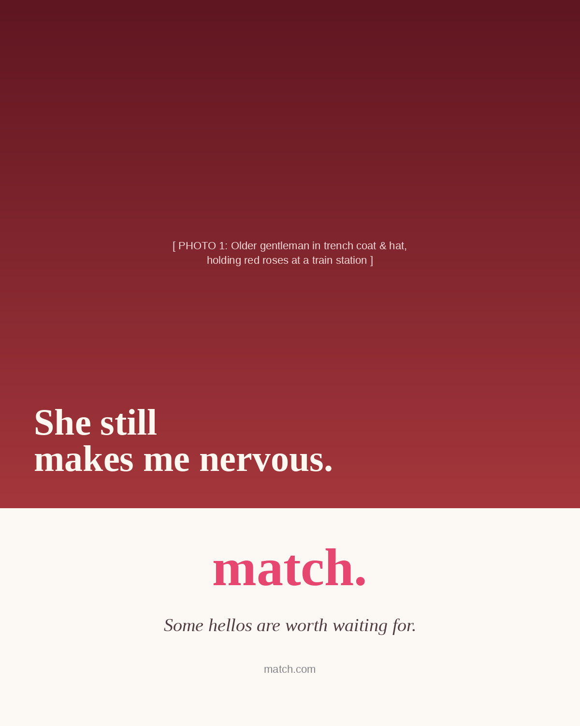
Photo: Older gentleman in trench coat with red roses at a train station
Brand: Match
Headline: “She still makes me nervous.”
Tagline: “Some hellos are worth waiting for.”

Concept
I read this photo as a love story already in motion. Match is the dating brand that has always positioned itself for serious, lasting relationships rather than quick swipes — so I imagined this man as someone who met his wife on Match years ago and is still picking her up at the station with roses. The headline is a quiet confession in his voice, not a sales pitch. “She still makes me nervous” inverts every assumption about long-term relationships getting boring; it makes a 70-year-old man sound like a teenager again.

Why it’s effective
The concept works because Match competes in a category dominated by youth, gamification, and Tinder-style irreverence. By going emotional and mature, the ad differentiates the brand on the one axis competitors won’t touch: depth. The visual lockup uses a serif headline (slower, more literary) over a warm burgundy zone (the rose, the romance, the patina of time), and the cream brand zone with the iconic Match wordmark and italicized tagline keeps the layout calm. The line “Some hellos are worth waiting for” works double duty — it’s a romantic truth and a category-defining promise.

Ad 2: Spotify — Photo 2
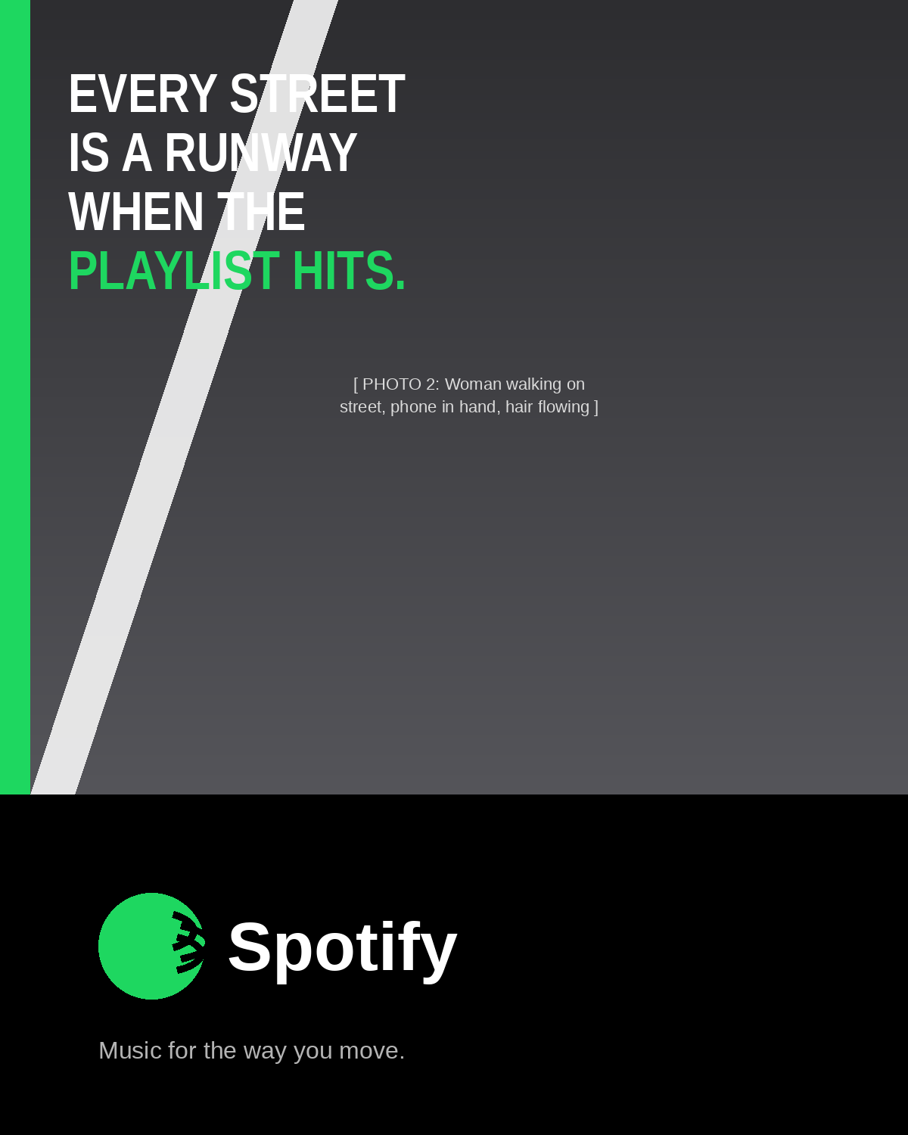
Photo: Woman walking on a street, phone in hand, hair flowing in motion
Brand: Spotify
Headline: “Every street is a runway when the playlist hits.”
Tagline: “Music for the way you move.”

Concept
The photo has obvious motion energy — the wind in her hair, the diagonal pavement marking, the confident stride. I wanted to claim that universal feeling everyone has had: the right song hits and suddenly your walk to class becomes a movie. Spotify is the brand that owns the connection between music and identity, so the ad isn’t about audio quality or library size — it’s about how music makes you feel about yourself.

Why it’s effective
The line is structurally a metaphor (“runway”), which Carnegie-era copywriting would call a “self-concept idea” — it lets the reader cast themselves as the main character. The condensed bold sans serif headline reinforces forward motion. Spotify green is reserved as an accent color so the eye lands on “PLAYLIST HITS” — the punch line. Black brand zone keeps the design culturally cool (Spotify’s house style trends dark and bold), and the tagline “Music for the way you move” ties the abstract feeling back to the product benefit without being preachy.

Ad 3: Nike — Photo 3
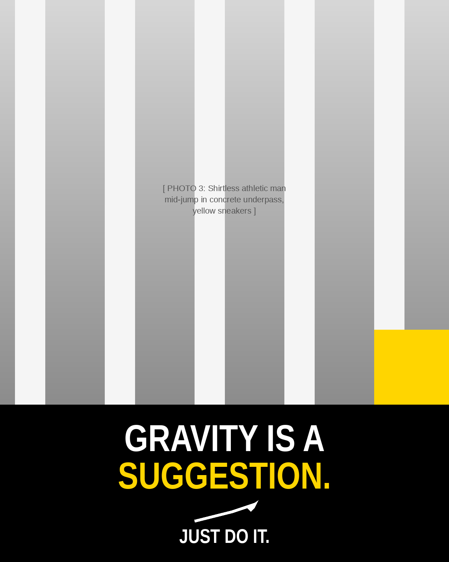
Photo: Shirtless athletic man mid-jump in concrete underpass with yellow sneakers
Brand: Nike
Headline: “Gravity is a suggestion.”
Tagline: “Just Do It.”

Concept
The photo is already a Nike ad waiting to happen — mid-air, defying physics, yellow shoes as the hero. I leaned into that and wrote a single bold declarative line. “Gravity is a suggestion” personifies physics as something you can negotiate with, which fits Nike’s 50-year tradition of writing copy that treats physical limits as mental limits. The line is short enough to live on a billboard, a side of a shoebox, or a 6-second pre-roll.

Why it’s effective
Nike’s brand voice is bold, irreverent, and aspirational — never instructional. This headline does what “Just Do It” does: it reframes the activity as a posture, not a task. Visually, I echoed the underpass’s vertical concrete columns to ground the ad in the photo’s setting, and used a yellow accent block to pull the shoe color into the brand zone for color continuity. The all-caps condensed type, black field, and white/yellow color hierarchy match Nike’s standard system. “Just Do It” below the swoosh closes the lockup the way every Nike ad has since 1988 — it’s not the hero line here, it’s the brand stamp.

Ad 4: Patagonia — Photo 4
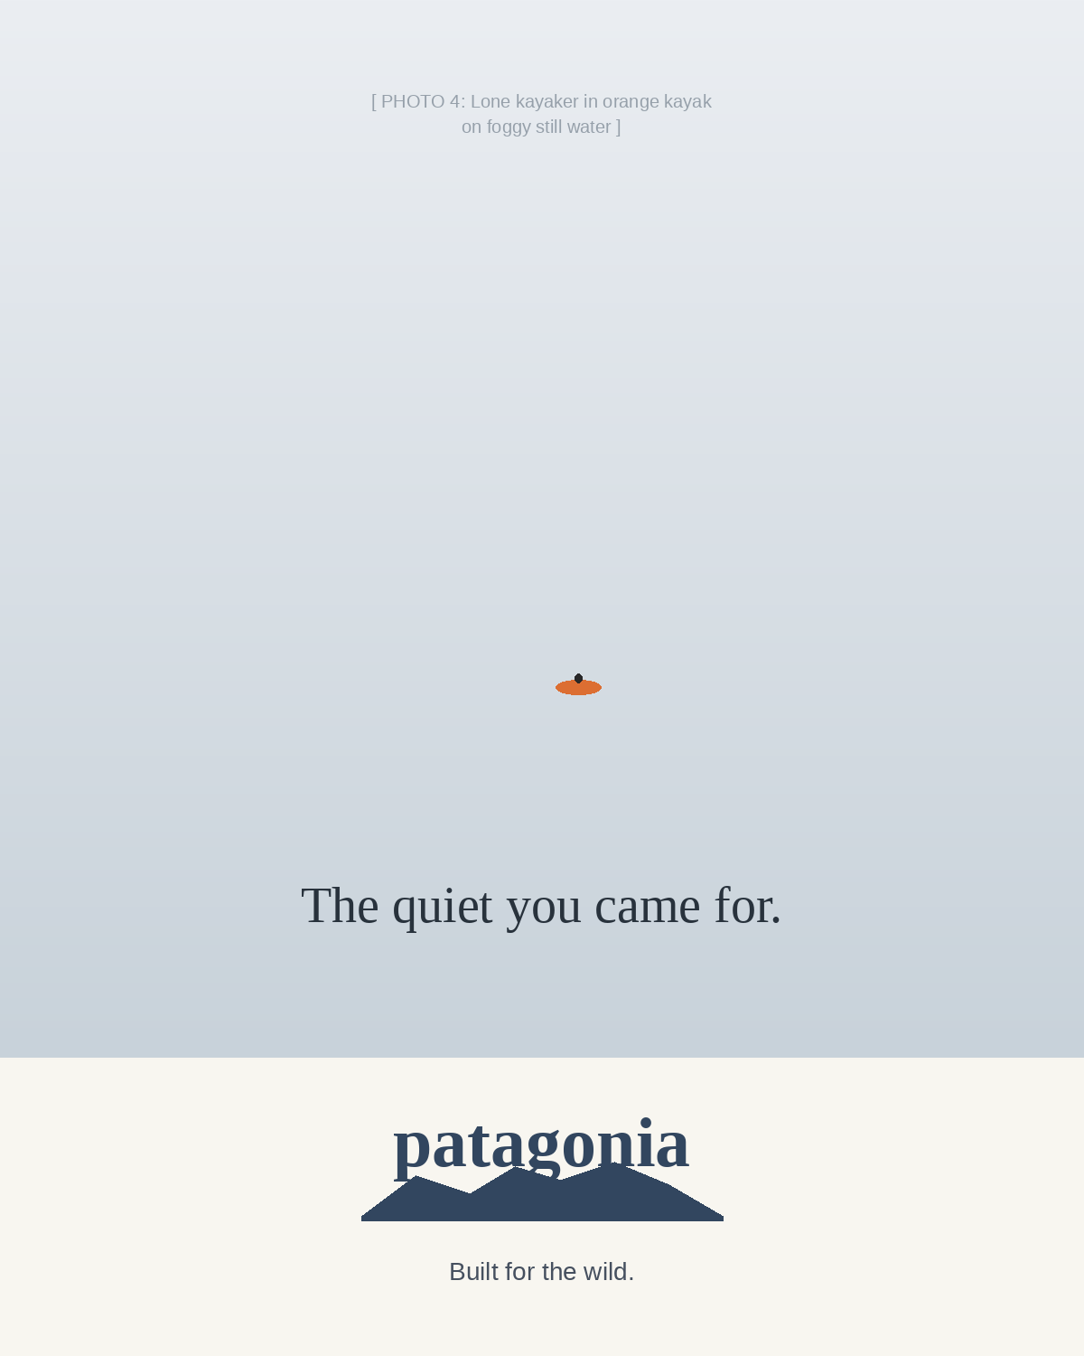
Photo: Lone kayaker in an orange kayak on foggy still water
Brand: Patagonia
Headline: “The quiet you came for.”
Tagline: “Built for the wild.”

Concept
The photo is the ad. There’s one human being on still water in fog, and the only color in the frame is the orange of the kayak. Patagonia’s brand is built on quiet reverence for the outdoors, not adrenaline marketing, so I wrote a small line that doesn’t sell anything — it just names what you’re looking at. “The quiet you came for” acknowledges the reader’s motivation rather than projecting one onto them.

Why it’s effective
Patagonia’s voice is restrained almost to the point of being anti-advertising — they’ve famously run “Don’t Buy This Jacket” ads on Black Friday. The design follows that ethos: enormous negative space, a small serif headline, and the brand mark below the iconic mountain horizon. Importantly, the design does not shout product features (waterproof rating, fabric tech, etc.). It earns trust by sounding like a friend who gets it, not a brand selling you something. This restraint is also strategically effective — in a category full of REI/North Face/Columbia ads competing on specs, Patagonia wins by competing on values.

Ad 5: Casper — Photo 6
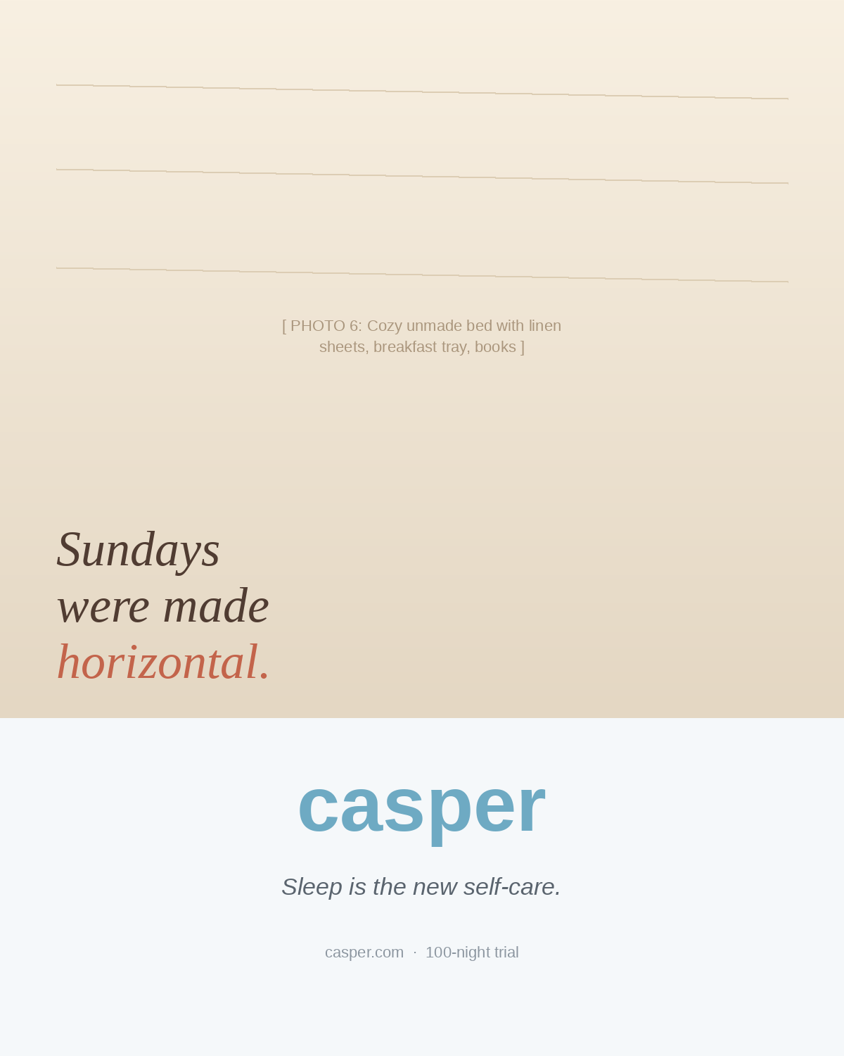
Photo: Cozy unmade bed with linen sheets, breakfast tray, and books
Brand: Casper
Headline: “Sundays were made horizontal.”
Tagline: “Sleep is the new self-care.”

Concept
The photo captures a universal feeling — the slow Sunday, the breakfast in bed, the books you said you’d read. Casper has always positioned itself as the brand that elevates rest into a lifestyle category (not just a product), so I wrote a witty line that gives readers permission to do nothing. “Sundays were made horizontal” plays on the idea that some days have a designated posture — and Sunday’s is lying down.

Why it’s effective
Casper’s brand voice is warm, clever, and conversational, with a sense of humor that doesn’t take itself too seriously (their subway ads with bedtime puns are textbook). The italic serif headline feels like handwriting, which keeps the tone intimate. The cream gradient evokes linen, and the soft Casper blue brand zone feels calm rather than corporate. The tagline “Sleep is the new self-care” ties Casper into the broader wellness conversation — it positions the mattress as a wellness purchase, not a furniture purchase, which is exactly how the brand has elevated its category and pricing.

